# Kathmandu University

**Department of Computer Science and Engineering Dhulikhel, Kavre**

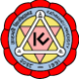

# Mini Report on

**“Lab 1”**

# [Course Code: COMP 342]

**(For partial fulfillment of III Year/ I Semester in Computer Science)**

# Submitted By

**Nisham Ghimire (22)**

# Submitted To

**Mr. Dhiraj Shrestha**

**Department of Computer Science and Engineering**

# Submission Date

**5th October, 2023**

1. **Mention the name of the Programming language and Graphics Library you are using this semester for performing your Computer Graphics Lab and Project.**

**Ans:**

I am using Python as my primary programming language. Graphics Library Used are:

* + Opengl
  + Glfw
  + Pygame
  + Turtle etc.

1. **Write the code snippets for setting graphics environment in your chosen graphics library and display the resolution of your display system through functions/classes provided by your graphics library.**

**Ans:**

Code snippets are:

import glfw

def main():

    if not glfw.init():

        return

    monitor = glfw.get_primary_monitor()

    mode = glfw.get_video_mode(monitor)

    width, height = mode.size.width, mode.size.height

    print("Screen resolution: {}x{}".format(width, height))

    glfw.terminate()

if __name__ == "__main__":

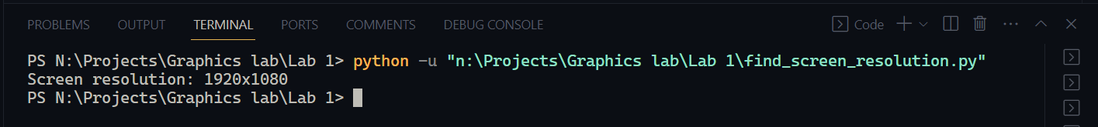    main()

­­­­­

1. **Get Familiar with the coordinate system and draw a flag of Nepal using the chosen Graphics geometrical functions/ classes provided by the your chosen graphics library and also color the flag accordingly.**

**Output:**

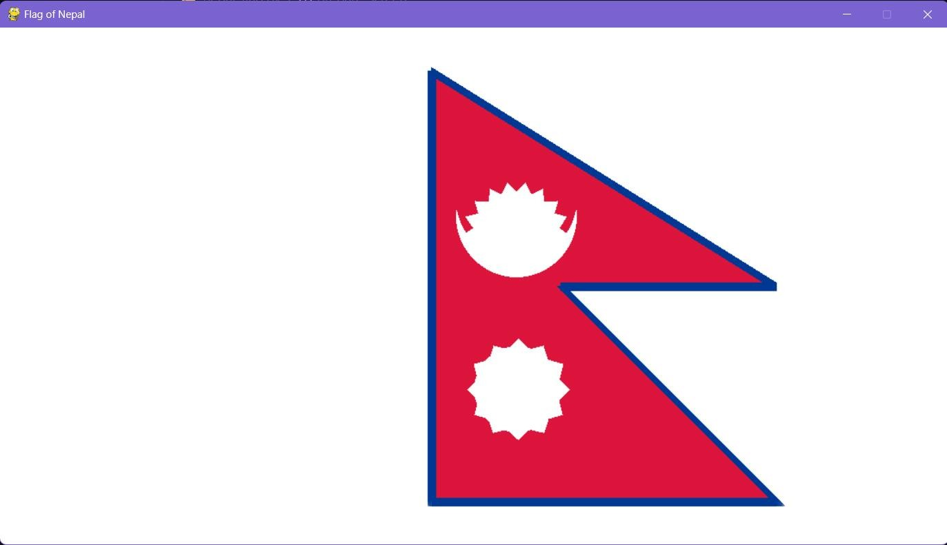

## Code:

import pygame

import math

from pygame.locals import *

from OpenGL.GL import *

from OpenGL.GLU import *

*# Function to draw a circle using the specified parameters*

def draw_circle(x, y, radius, num_segments, n):

    glBegin(GL_TRIANGLE_FAN)

    glVertex2f(x, y)

    for i in range(num_segments + 1):

        theta = n * math.pi * float(i) / float(num_segments)

        dx = radius * math.cos(theta)

        dy = radius * math.sin(theta)

        glVertex2f(x + dx, y + dy)

    glEnd()

*# Function to draw attributes of the flag*

def draw_flag_attributes(x, y, radius, num_segments, n):

    draw_circle(x, y, radius, num_segments, n)

    for i in range(num_segments):

        glBegin(GL_TRIANGLES)

        theta1 = n * math.pi * float(i) / float(num_segments)

        x1 = x + radius * math.cos(theta1)

        y1 = y + radius * math.sin(theta1)

        theta2 = n * math.pi * float(i + 1) / float(num_segments)

        x2 = x + radius * math.cos(theta2)

        y2 = y + radius * math.sin(theta2)

        glVertex2f(x1, y1)

        glVertex2f(x2, y2)

        glVertex2f(((x1 + x2) / 2) + ((x1 + x2 - 2 * x) / 2), ((y1 + y2) / 2) + ((y1 + y2 - 2 * y) / 2))

        glEnd()

*# Function to draw the flag of Nepal*

def draw_nepal_flag():

    pygame.init()

    display = (800, 600)

    pygame.display.set_mode(display, DOUBLEBUF | OPENGL)

    while True:

        for event in pygame.event.get():

            if event.type == pygame.QUIT:

                pygame.quit()

                quit()

*# Red triangle on top of the flag*

        glBegin(GL_TRIANGLES)

        glColor3f(0.8627, 0.0784, 0.2353)

        glVertex2f(0.0, 0.0)

        glVertex2f(0, 0.5)

        glVertex2f(0.75, 0)

        glEnd()

*# Red triangle on the bottom of the flag*

        glBegin(GL_TRIANGLES)

        glColor3f(0.8627, 0.0784, 0.2353)

        glVertex2f(0, 0.25)

        glVertex2f(0, -0.5)

        glVertex2f(0.75, -0.50)

        glEnd()

*# Blue quadrilateral on the flag*

        glBegin(GL_QUAD_STRIP)

        glColor3f(0.0, 0.2196, 0.5765)

        glVertex2f(0.00, -0.50)

        glVertex2f(0.00, 0.50)

        glVertex2f(-0.045, -0.50)

        glVertex2f(-0.045, 0.575)

        glEnd()

*# Additional blue quadrilaterals on the flag*

        glBegin(GL_QUAD_STRIP)

        glColor3f(0.0, 0.2196, 0.5765)

        glVertex2f(0.00, 0.50)

        glVertex2f(-0.05, 0.585)

        glVertex2f(0.75, -0.05)

        glVertex2f(0.825, -0.05)

        glEnd()

        glBegin(GL_QUAD_STRIP)

        glColor3f(0.0, 0.2196, 0.5765)

        glVertex2f(0.75, 0.00)

        glVertex2f(0.75, -0.05)

        glVertex2f(0.248, 0.00)

        glVertex2f(0.30, -0.05)

        glEnd()

        glBegin(GL_QUAD_STRIP)

        glColor3f(0.0, 0.2196, 0.5765)

        glVertex2f(0.75, -0.545)

        glVertex2f(0.810, -0.545)

        glVertex2f(0.30, -0.05)

        glVertex2f(0.357, -0.05)

        glEnd()

        glBegin(GL_QUAD_STRIP)

        glColor3f(0.0, 0.2196, 0.5765)

        glVertex2f(-0.045, -0.50)

        glVertex2f(-0.045, -0.545)

        glVertex2f(0.75, -0.50)

        glVertex2f(0.75, -0.545)

        glEnd()

        glColor3f(0.8275, 0.8275, 0.8275)

*# Draw circles on the flag*

        draw_circle(0.18, 0.20, 0.1, 100, 2)

        glColor3f(0.8627, 0.0784, 0.2353)

        draw_circle(0.18, 0.24163, 0.09, 100, 2)

*# Draw specific attributes on the flag*

        glColor3f(0.8275, 0.8275, 0.8275)

        draw_flag_attributes(0.20, -0.30, 0.065, 12, 2)

        glColor3f(0.8275, 0.8275, 0.8275)

        draw_flag_attributes(0.18, 0.1525, 0.05, 10, 1)

        pygame.display.flip()

*# Call the function to draw the Nepal flag*

draw_nepal_flag()

**Conclusion**:

## After completing this lab work, I learned about creating windows and drawing various structures in the window, providing them with colors and dimensions. I learned to create and integrate triangles, circles and stars that can be found in Nepal flag.